**INFORMATION AND COMMUNICATION TECHNOLOGIES (TIC)**  
Modern Tools and Digital Platforms  
  
Prepared by: Benmakhloufi Zohair  
Field: Computer Science  
University: USTHB  
Module: ICT  
Academic Year: 2025–2026

Table des matières

1. Introduction to ICT 1

2. Components of ICT 2

3. Importance of ICT in Modern Society 3

4. Google Services and Tools 4

5. Microsoft Tools and Platforms 5

6. Git and GitHub 6

7. Other Technologies Related to ICT 7

8. Advantages and Disadvantages of ICT 8

9. Conclusion 10

# 1. Introduction to ICT

Information and Communication Technologies (ICT) refer to the set of technologies used to create, store, process, and exchange information. ICT combines computing, telecommunications, and digital media.  
  
In the modern world, ICT has become essential in almost every sector, including education, business, healthcare, government, and entertainment. It enables fast communication, automation, and access to information.

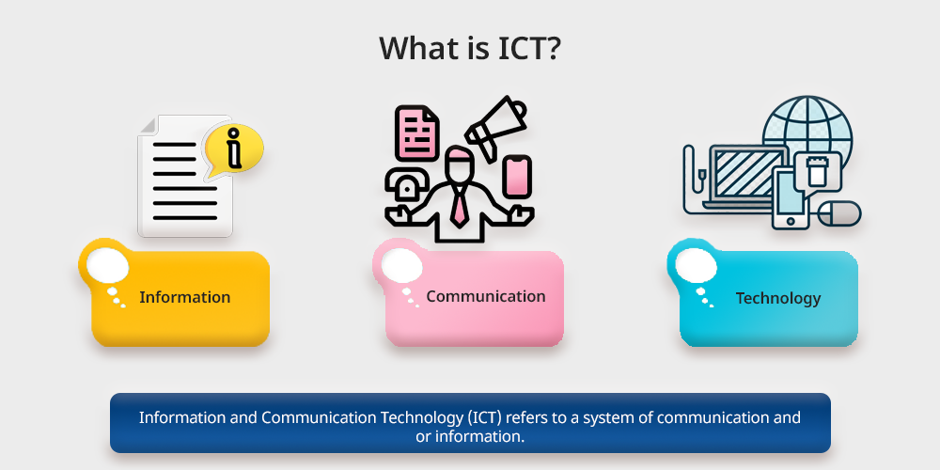

# 2. Components of ICT

ICT systems are composed of several interconnected components that work together to process and transmit information.  
  
Hardware includes physical devices such as computers, servers, smartphones, routers, and printers.  
  
Software includes operating systems, applications, and development tools.  
  
Networks allow devices to communicate through the internet, LAN, or wireless technologies.  
  
Data represents the information being processed, such as text, images, audio, and video.

|  |  |
| --- | --- |
| Component | Examples |
| Hardware, Software, Networks, Data | Computers, Applications, Internet, Multimedia |

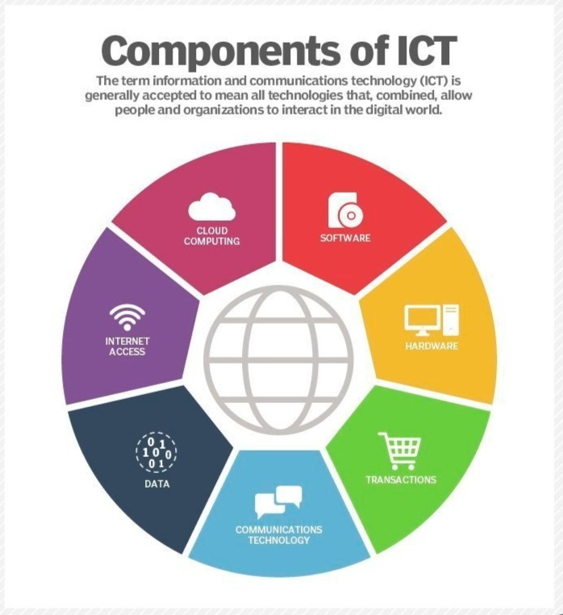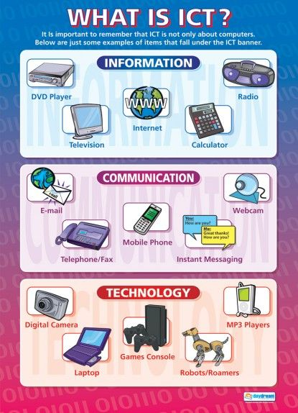

# 3. Importance of ICT in Modern Society

ICT plays a critical role in improving efficiency, productivity, and communication.  
  
In education, ICT enables online learning platforms, virtual classrooms, and digital resources.  
  
In business, ICT supports e-commerce, digital marketing, cloud computing, and remote work.  
  
In healthcare, ICT allows telemedicine, electronic medical records, and advanced diagnostics.

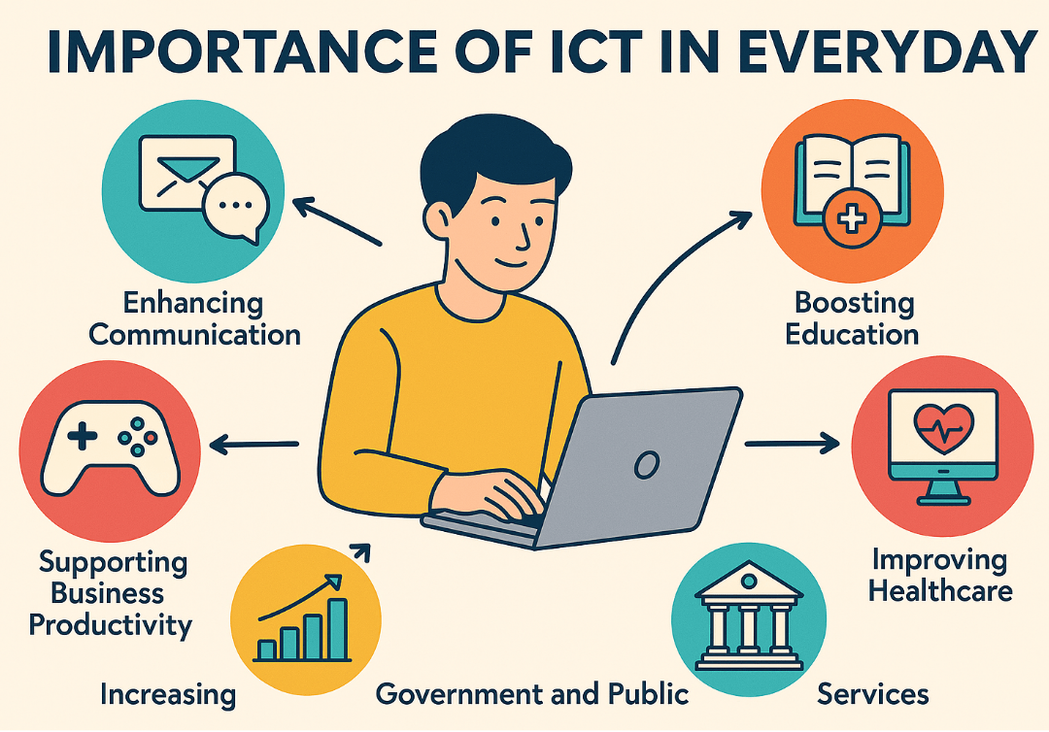

# 4. Google Services and Tools

Google offers a wide range of cloud-based ICT services that enhance productivity and collaboration.  
  
Google Workspace includes Google Docs, Sheets, Slides, and Drive, which allow real-time collaboration.  
  
Gmail and Google Meet provide communication through email and video conferencing.  
  
Google Cloud Platform (GCP) offers infrastructure and services for hosting applications and data.

|  |  |
| --- | --- |
| Service | Purpose |
| Google Docs, Drive, Gmail, Meet | Cloud collaboration and communication |

For example these are one of google services Google Cloud :

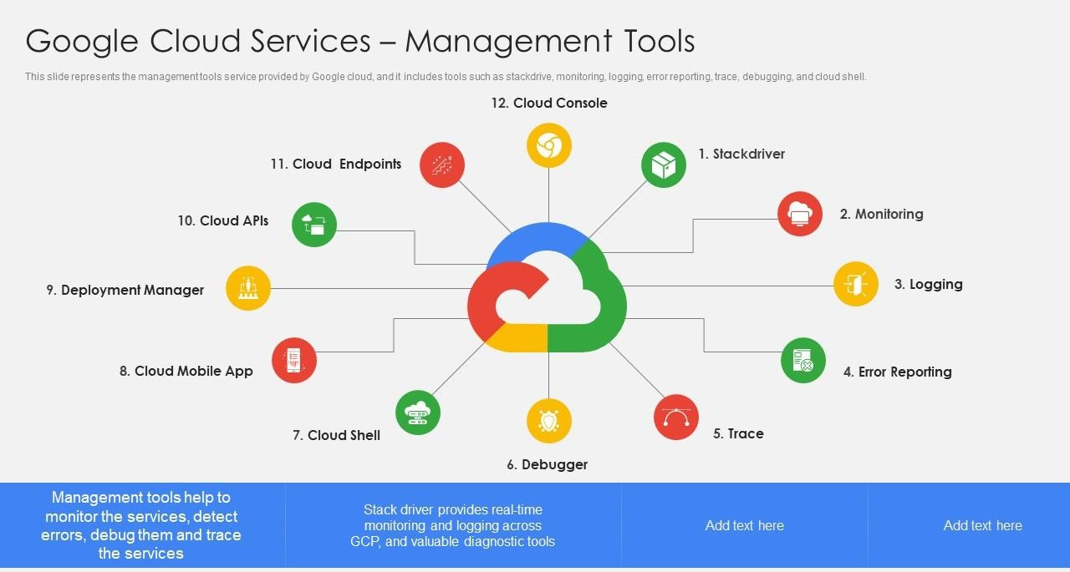

# 5. Microsoft Tools and Platforms

Microsoft is one of the leading providers of ICT solutions worldwide.  
  
Microsoft Office tools such as Word, Excel, and PowerPoint are widely used for documentation, data analysis, and presentations.  
  
Windows is one of the most popular operating systems.  
  
Microsoft Teams and OneDrive enable communication and cloud storage, while Azure provides cloud computing services.

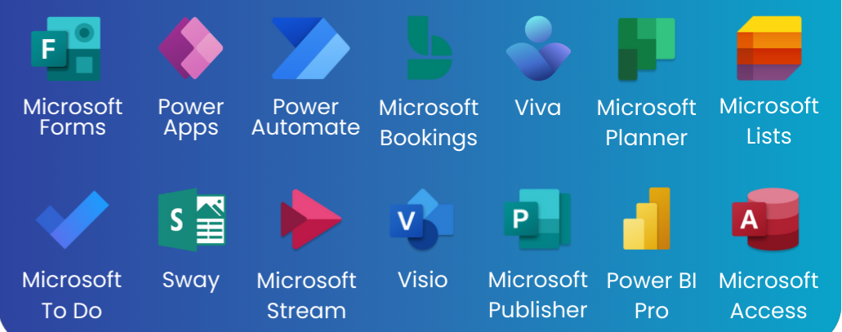

# 6. Git and GitHub

Git is a distributed version control system that allows developers to track changes in source code.  
  
It helps manage different versions of a project and supports collaboration through branching and merging.  
  
GitHub is an online platform that hosts Git repositories and provides tools for collaboration, issue tracking, and open-source development.

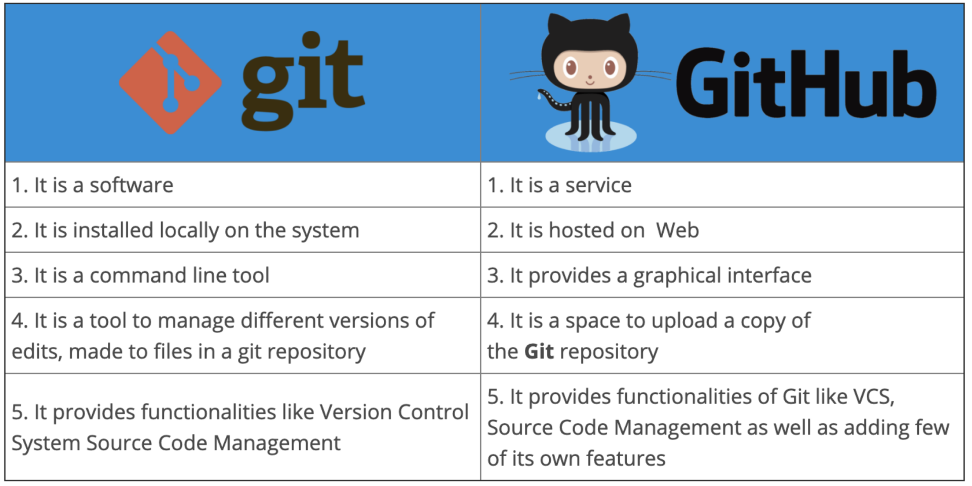

# 7. Other Technologies Related to ICT

Several modern technologies are closely related to ICT and extend its capabilities.  
  
Cloud Computing allows access to computing resources over the internet.  
  
Artificial Intelligence (AI) enables machines to simulate human intelligence.  
  
The Internet of Things (IoT) connects physical devices to the internet.  
  
Cybersecurity protects systems and data from digital threats.

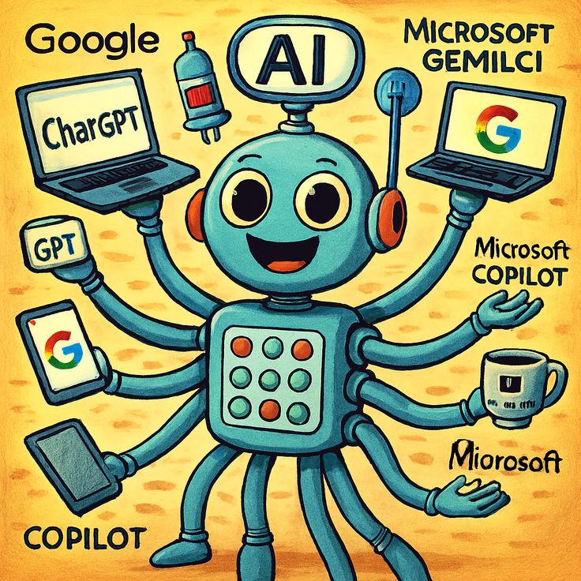

# 8. Advantages and Disadvantages of ICT

Advantages of ICT include fast communication, global connectivity, automation of tasks, and easy access to information. These benefits have made ICT an essential tool in many fields of modern society. In addition to improving efficiency and productivity, ICT has positively impacted several important sectors such as education, agriculture, healthcare, finance, e-commerce, entertainment, and even political and military operations. The following figure illustrates the main areas where ICT plays a significant role.

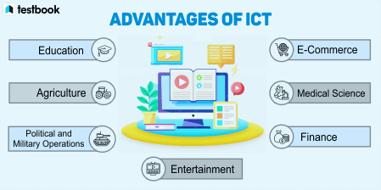

However, ICT also has disadvantages such as cybersecurity risks, dependence on technology, distraction, health issues, privacy concerns, digital addiction, and job displacement due to automation.

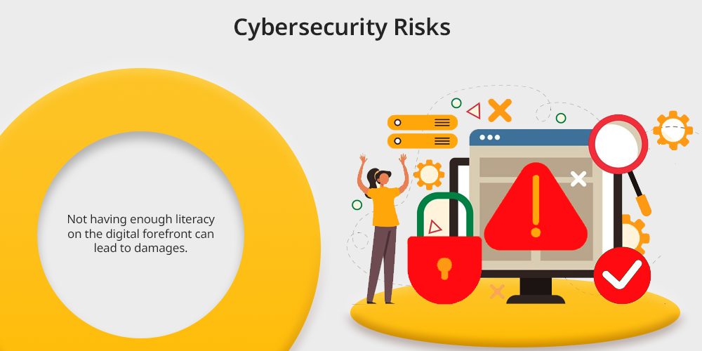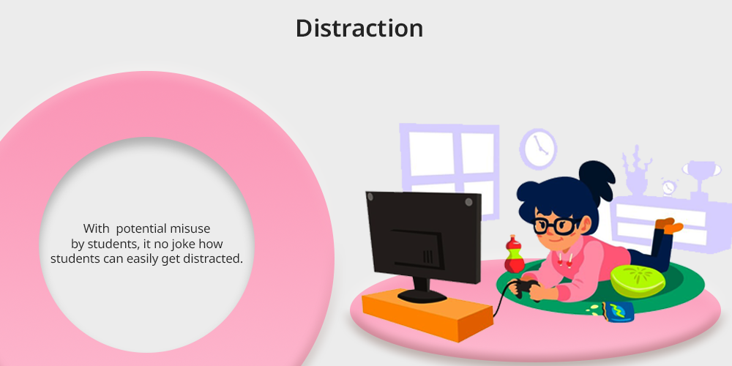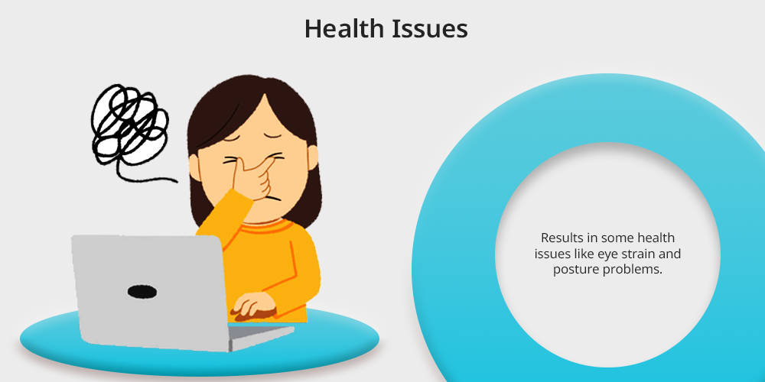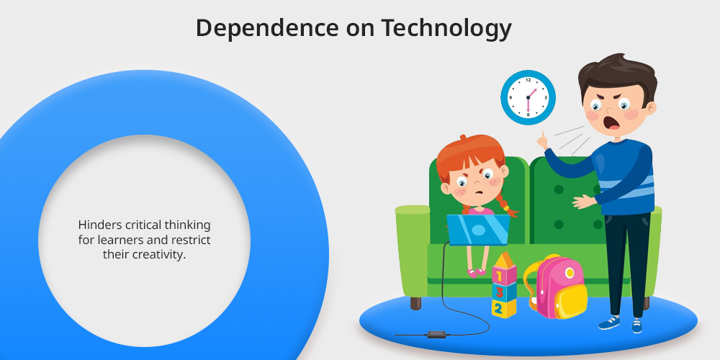

For example here are the advantages and disadvanteges of ICT in Education:

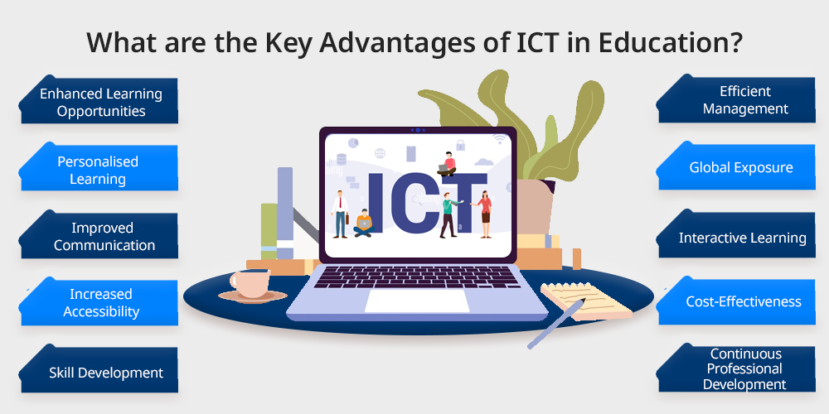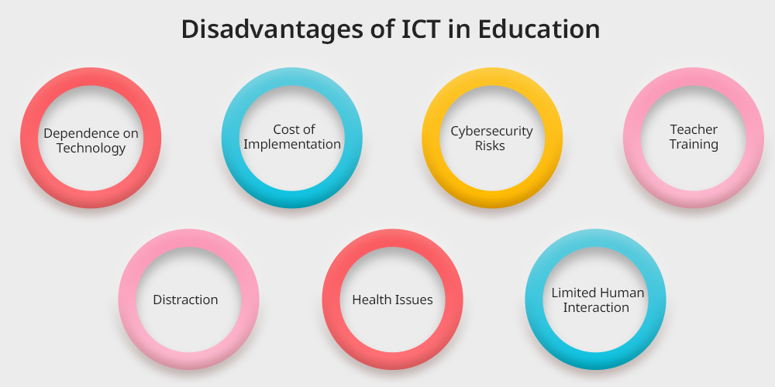

# 9. Conclusion

Information and Communication Technologies have transformed the way people live and work.  
  
Tools such as Google services, Microsoft platforms, and GitHub have improved collaboration and productivity.  
  
Despite certain challenges, ICT continues to evolve and will remain a key driver of innovation in the future.